Use Case Overview

Assignment in the course PA1415 Programvarudesign

2017 - 04 - 04

|  |  |  |  |
| --- | --- | --- | --- |
| Author Name | Social Security Nr | Thinking | Writing |
| Jonatan Fransson | 901118 | 9%9 |  |
| Teemu Hiirikoski | 970920 | 1 == 2 |  |
| Jakob Strand | 920514 |  |  |
| Noah Håkansson | 970328 |  |  |

Creating a nethack game with the use of twitter to randomly generate environments, items and other objects within the game.

Use Case Diagram

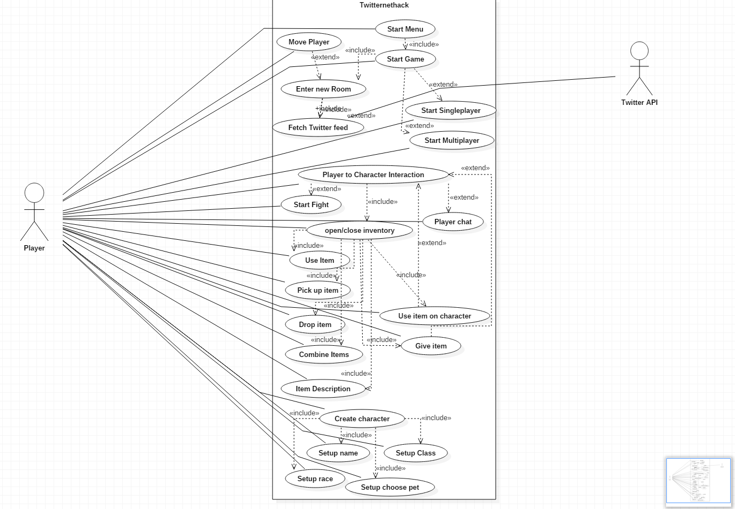

Dictionary:

Actors: Twitter API, Player

Twitter API is used to scan a twitter feed for keywords that the system will be using in order to randomly generate rooms, items, non-playable characters and players statistics.

Player is the end user. A player playing the game.

High-Level use cases

Move Player

Actor: Player

Description: The player is moved in the given direction.

Scenario: The player moves around the current zone.

Alternative flow of events: There is a wall in front of the player and they can’t move.

Concerned user stories: E.2.3

------------------------------------------------------------------------------------------------------------------------

Start Game

Actor: Player

Description: The system starts the game and generates the first room.

Scenario: The player feels satisfied with the character and decides to start the game and use case: “Enter new room” is called.

Alternative flow of events: The player is not satisfied and decides to remake the character.

Concerned user stories: E.2

------------------------------------------------------------------------------------------------------------------------

Fetch Twitter feed

Actor: System

Description: The system collects data from a random twitter feed through the twitter api.

Scenario: The system picks a random twitter feed and collects data from it.

Alternative flow of events: The system tries to connect to to twitter but fails because twitter is down.

Concerned user stories: E.2.5

------------------------------------------------------------------------------------------------------------------------

Enter new room

Actor: Player

Description: The player exits a room and enters a newly generated one.

Scenario: Player enters a new room and the system calls use case: “fetch twitter feed” and uses data to generate a random room.

Alternative flow of events: Door is locked and player can’t enter a new room.

Concerned user stories: E.2

------------------------------------------------------------------------------------------------------------------------

Player to character interaction

Actor: Player

Description: Player interacts with other characters through talking, trading items and being able to use items on each other.

Scenario: Player chooses to start a conversation with another character in the room, a conversation dialog is opened.

Alternate flow of events: Player interacts with another player but the other player disconnects.

Concerned user stories: E.6

------------------------------------------------------------------------------------------------------------------------

Start fight

Actor: Player

Description: Player attacks another character and they start fighting.

Scenario: The player chooses to begin a fight with another character.

Alternative flow of events: The game character does not want to fight and flees.

Concerned user stories: E.6

------------------------------------------------------------------------------------------------------------------------

Item description

Actor: Player

Description: Player reads the description of an item.

Scenario: The player reads the description of an item in the inventory. Use case: “Open/Close inventory” is called.

Alternative flow of events: The item has no description.

Concerned user stories:E.3

-----------------------------------------------------------------------------------------------------------------------

Combine Items

Actor: Player

Description: Player combines two or more items.

Scenario: Two items are combined to create a new ite and the new item is put in the player inventory. Use case: “Open/Close inventory” is called.

Alternative flow of events: the items are destroyed and lost.

Concerned user stories: E.3

------------------------------------------------------------------------------------------------------------------------

Use Item

Actor: Player

Description: Player uses an item from the player inventory.

Scenario: Player opens inventory and selects an item to be used. Use case: “Open/Close inventory” is called.

Alternative flow of events: Player tries to use an item but the item may only be used under certain circumstances, tries to use key but no door is nearby.

Concerned user stories: E.3

------------------------------------------------------------------------------------------------------------------------

Pick up item

Actor: Player

Description: Player picks up Item from the ground.

Scenario: Item is picked up and is placed in player inventory. Use case: “Open/Close inventory” is called.

Alternative flow of events: The player’s inventory is full.

Concerned user stories: E.3.3, E.4

------------------------------------------------------------------------------------------------------------------------

Drop item

Actor: Player

Description: Player drops item on the ground.

Scenario: The player chooses an item from the inventory to be dropped on the ground.

Use case: “Open/Close inventory” is called.

Alternative flow of events: The player has an empty inventory and nothing happens.

Concerned user stories: E.3.4

------------------------------------------------------------------------------------------------------------------------

Give item

Actor: Player

Description: An item is traded between two players.

Scenario: A player opens player inventory and selects an item to be trade to another player in the same area. Use case: “Open/Close inventory” is called.

Alternative flow of events: Traded items are duplicated and both players has them.

Concerned user stories: E.3

------------------------------------------------------------------------------------------------------------------------

Use item on character

Actor: Player

Description: An item is used on a player.

Scenario: Use case “Use Item” is called and proceeds to use item on player two.

Alternative flow of events: Player is too far away.

Concerned user stories: E.3

------------------------------------------------------------------------------------------------------------------------

Open/Close Inventory

Actor: Player

Description: The player opens or closes the player’s inventory tab.

Scenario: The player opens the inventory and searches for an item.

Alternative flow of events: Inventory tab does not work and nothing happens.

Concerned user stories: E.3, E.4

------------------------------------------------------------------------------------------------------------------------

Player chat

Actor: Player

Description: Players can send messages.

Scenario: Players opens a chat window and writes a message to another nearby player.

Alternative flow of events: Message is not received and is lost in cyberspace.

Concerned user stories: E.6

------------------------------------------------------------------------------------------------------------------------

Start menu

Actor: Player

Description: After the player launches the application a game menu is presented to the player.

Scenario: The player is presented with different menu items to choose from.

Alternative flow of events: Game crashes

Concerned user stories: E1

------------------------------------------------------------------------------------------------------------------------

Start new single-player game

Actor: Player

Description: The player starts a new single player game.

Scenario: Player plays alone without other players and starts single player mode and use case: “Create character” is called.

Alternative flow of events: Player decided to load an existing game.

Concerned user stories: E1, E5

------------------------------------------------------------------------------------------------------------------------

Start multiplayer game

Actor: Player

Description: The system starts a multiplayer game.

Scenario: A player starts a multiplayer game and use case: “Create character” is called.

Alternative flow of events: The player joins an already existing multiplayer game.

Concerned user stories: E1, E5

------------------------------------------------------------------------------------------------------------------------

Create character

Actor: Player

Description: Uses all Setup use cases, lets the player create a character.

Scenario: The player creates a character.

Alternative scenario: The player cancels the creation of the character.

Concerned user stories: E5

------------------------------------------------------------------------------------------------------------------------

Setup - name

Actor: Player

Description: The system requires a name from the player.

Scenario: The player is prompted with a textfield to enter a name.

Alternative flow of events: A player has no name, that is the player's new name.

Concerned user stories: E5.3

------------------------------------------------------------------------------------------------------------------------

Setup - race

Actor: Player

Description: The system requires the player to choose a race.

Scenario: The player is prompted with choices of different races to choose from.

Alternative flow of events: Player is now another race.

Concerned user stories:E5.1

------------------------------------------------------------------------------------------------------------------------

Setup - class

Actor: Player

Description: The system requires the player to choose a class.

Scenario: The player is prompted with a set of different classes to choose from.

Alternative flow of events: Player chooses another available class role.

Concerned user stories: E5.2

------------------------------------------------------------------------------------------------------------------------

Setup - choose pet

Actor: Player

Description: The system requires the player to choose a companion-pet.

Scenario: The player is prompted with a set of companion pets to choose from.

Alternative flow of events: The player is given a companion-pet by the system.

Concerned user stories: E5.6